**Capstone Project Final Assignment**

**Submitted by Rajaram Challa**

**Analysis of Chicago Neighborhoods**

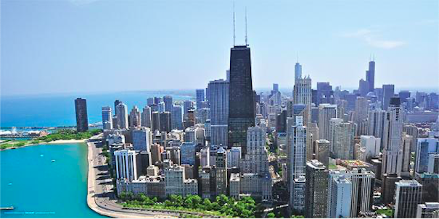

[**Chicago, Illinois Skyline**](https://www.google.com/url?sa=i&rct=j&q=&esrc=s&source=images&cd=&cad=rja&uact=8&ved=0ahUKEwiW44Gj1PHlAhUOTN8KHSZIBFwQMwigAigBMAE&url=https%3A%2F%2Fwww.allposters.com%2F-sp%2FIllinois-Chicago-Skyline-Posters_i14297732_.htm&psig=AOvVaw34jwNJfhxK1PD3O_eZ3w2d&ust=1574094277528216&ictx=3&uact=3)

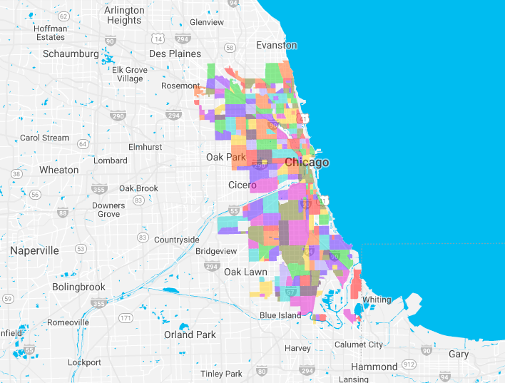

**Chicago Neighborhoods**

1. **Introduction**

So far, in my lifetime, I have moved over 20 times for education and for jobs. I now live in the USA after having lived in India and in the Middle East. Within the USA, I have lived in 10 different cities - not just for a casual visit, but actually established residence and lived - for a minimum of 6 months each.

When I was young and single the selection of the neighborhood to live in was straightforward. Now, with a family and school going kids the process is much more elaborate. While proximity to work / school is an important factor, we also relied on inputs from coworkers. In addition, the decision process relied on our family members’ subjective opinions based on observations during a Saturday morning apartment hunting trip:

* My daughter saying “dad, that school building looks new”
* My spouse saying “this strip mall has decent shops and appears to be safe”
* Me thinking “the rent in this area is within our budget”
* etc.

So far, many times, our gut feeling turned out to be OK, but not always. In the past we did not have as much quantitative data available as we have now-a-days. These days we have access to publicly available statistics on socio economic factors, demographic data, crime statistics from municipal, state and research / university sources. We can now augment this public data with commercial data such as Foursquare.

In this assignment I would like use Data Science techniques to make the selection process – of a neighborhood to live in less subjective and more quantitative, by comparing different neighborhoods based on attributes from socio-economic factors, crime data and Foursquare venues data.

For this assignment, I will choose one city (Chicago). In the future we should be able to expand the solution to cover any city of the user’s choice.

I am sure many other people move frequently and would benefit from such an analysis.

1. **Data**

I realize that the in-depth analysis, identifying correlations and clusters, drawing conclusions are heavily dependent on the available data. The availability of ***relevant*** and ***reliable*** data is of utmost importance to analyzing and solving any problem.

In a real-life business scenario, the organization will have inhouse historical data. To augment inhouse data, businesses routinely purchase data from external (syndication / industry) sources.

For my Capstone project, I will rely on data available from

* Foursquare venue data (as required by the assignment)
* Publicly made available demographic / crime / education data from municipal / state agencies; Examples such as
  + Chicago Crime Data (from a previous Coursera Course)
  + Chicago Public School Data (from a previous Coursera Course)
  + Data from websites such as apartments.com

In the Venues data from Foursquare I will look for apartments and train stations.

Additional information on the location of the data sets and the attributes in available in the **Reference Section** at the end of this document.

Since these data sources are likely to have disparate data, I will apply data preparation, data cleansing and data filtering techniques to make the data useful for my analysis.

1. **Methodology**

In this assignment we will focus our efforts on identifying ‘good schools’ in higher per-capita neighborhoods with low incidents of crimes. We will limit this analysis to the City of Chicago.

Here are the steps I have followed in this assignment:

* Locate and map all the schools in the Chicago area.
* Identify schools that meet certain requirements.
  + Adequate Yearly Progress Made?
  + High SAFETY_SCORE
  + High AVERAGE_STUDENT_ATTENDANCE
* Analyze socio economic data and identify neighborhoods with a high per-capita income
  + Choose a high quantile(e.g. cse_sorted_df [‘per_capita_income_’].quantile(0.75)
* Use geocoders to obtain longitude and latitude for the selected neighborhoods
* Identify and map the locations of crimes (for entire Chicago)
  + Then focus on neighborhoods of interest
* Use Foursquare to locate Apartments and Train Stations
* Review the data produced and make it more useful by eliminating irrelevant rows and by correcting minor issues with the data
* Map Chicago “L” train stations in the selected neighborhoods
* Identify a couple of neighborhoods for further *physical* exploration

1. **Results**

My analysis shows that although there are a great number of schools in Chicago many were in areas of higher crime rates and lower per-capita income neighborhoods. By selecting “good” schools and higher per capita income areas we narrowed down the neighborhoods. Finally, I identified a couple of neighborhoods for further *physical* investigation.

* I started with 566 records for Chicago Public Schools

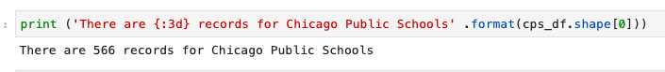

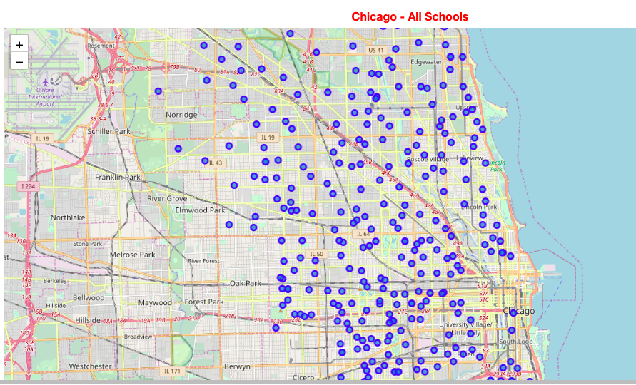

* 
* There are 72 relevant rows with a filter on Adequate Yearly Progress Made? attribute
  + cps_df['Adequate Yearly Progress Made? '] == 'Yes'
*  When I applied the filter on Safety Score attribute there are 128 relevant rows
  + I used .quantile against the SAFETY_SCORE attribute to choose schools with a high value
  + cps_df[cps_df['SAFETY_SCORE'] > cps_df['SAFETY_SCORE'].quantile(0.75)].
* 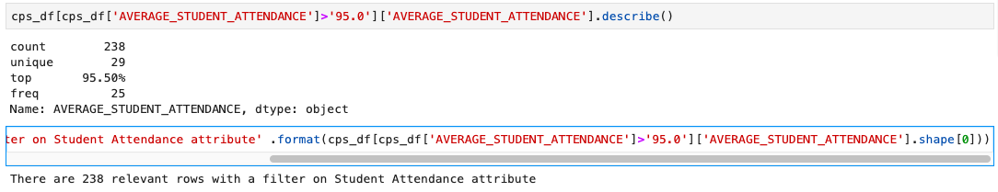 When I applied the filter on Student Attendance attribute there are 238 relevant rows
  + cps_df['AVERAGE_STUDENT_ATTENDANCE']>'95.0'
* When all applicable filters applied, there are 49 rows to work with. So, in effect, we reduced the raw schools count from 566 to 49 thus far.

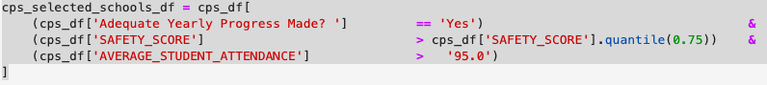



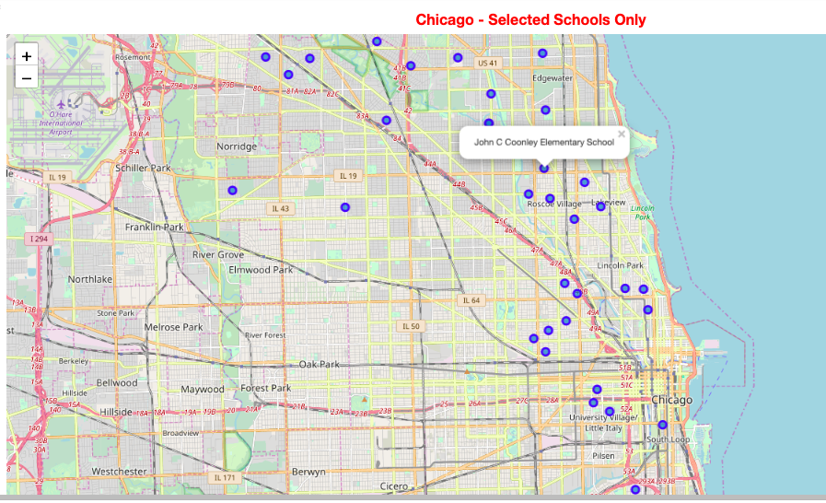

* I started with 78 rows in the Socio-Economic dataset



* 
* 
* I will use 31 neighborhoods that are in the top quartile of the socio-economic data for our analysis
* Notice that the per capita income range in
  + the selected neighborhoods is between $24,336 and $88,669 whereas
  + in the original data set the range was between $ 8,201 and $88,669
* Here are the top 20 neighborhoods:

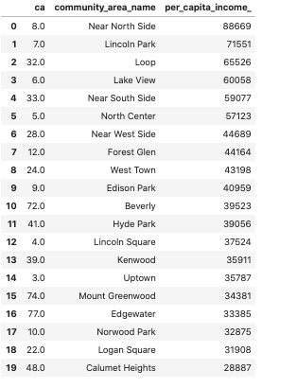

* 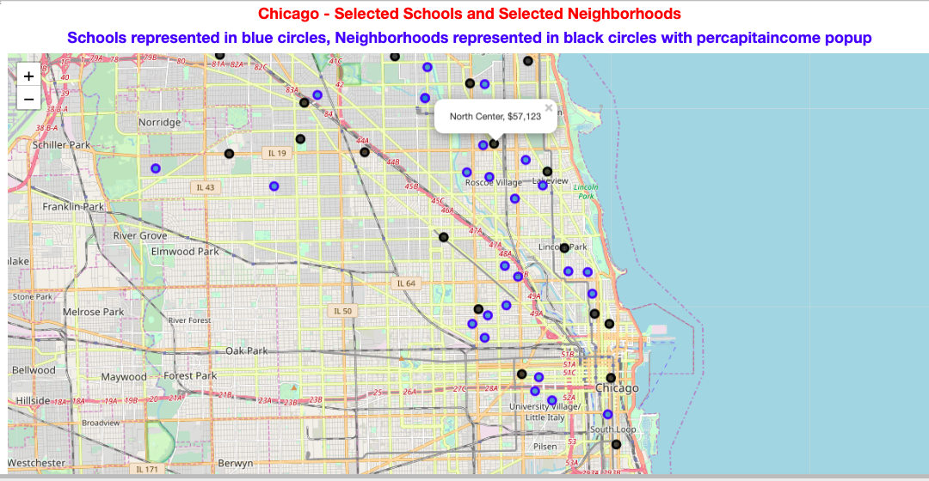
* 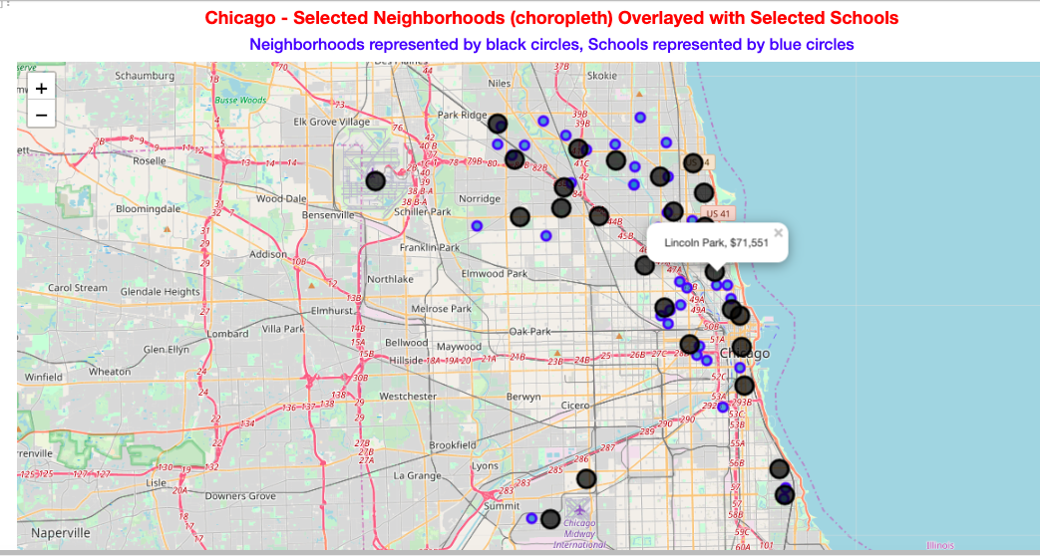
* *For some unknown reason my choropleth map stopped working. I am assuming because of a mismatch in the json data and the key_on parameter. I could not resolve the issue prior to the submission of this assignment. The following observations are from a previous iteration when choropleth map was working.*
* Here are few observations from the above choropleth map:
  + Near North Side, Lincoln Park, Loop have the highest per capita incomes.
  + Notice the bright red colors on choropleth map for Lincoln Park and Loop, but not for Near North Side
  + I verified and found that the geospatial data in the ChicagoGeoJSON file does not have data for Near North Side.
  + Lake View, North Center, West Town, Hyde Park, Edison Park, Norwood Park appear to have many Elementary Schools in their neighborhoods.
* Let us use Foursquare to locate venues in the neighborhoods. Of interest are apartments, train stations and Metro stations.
* From Foursquare documentation the category ids for apartments are:
* 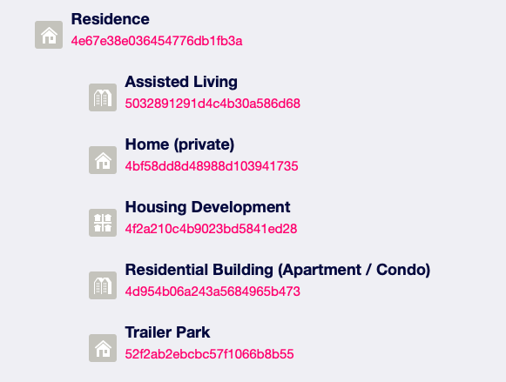
* Similarly, I looked up category ids for Train stations and Metro stations. The category id values I will search for are:
  + Apartments = '4d954b06a243a5684965b473'
  + TrainStation = '4bf58dd8d48988d129951735'
  + Metro = '4bf58dd8d48988d1fd931735'
* 
* There are 424 records in the venues (apartments, train stations) data set for our neighborhoods
* 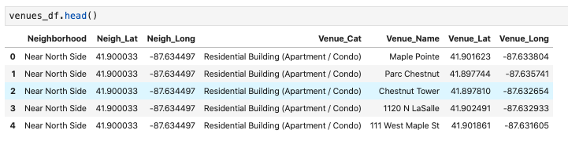
* 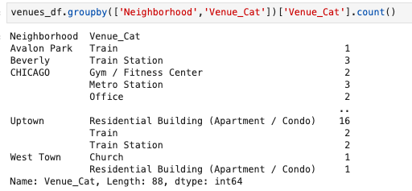
* 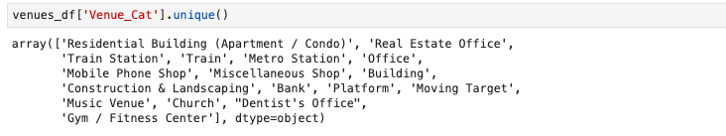Review the above groupby-count numbers and list of unique venue categories. Here are some observations:
  + Some neighborhoods don't have any apartments within our specified range (e.g. Beverly). This is probably a deficiency in Foursquare data.
  + We got some extraneous categories such as Mobile Phone Shops, Real Estate Office, Bank. Music Venue even though we did not ask for these. We will delete such extraneous venues
  + For our purposes Train, Train Station, Platform, Metro Station all mean the same. We will call these CTA-L. We will adjust the data frame with the updated category name as “CTA-L”
* There are 393 records in the venues (apartments, train stations) data set for our neighborhoods after deleting irrelevant rows
* 
* 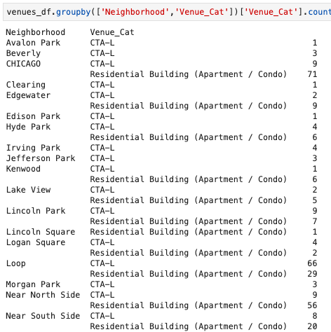
* As previously observed, not all neighborhoods have apartment venues.
* 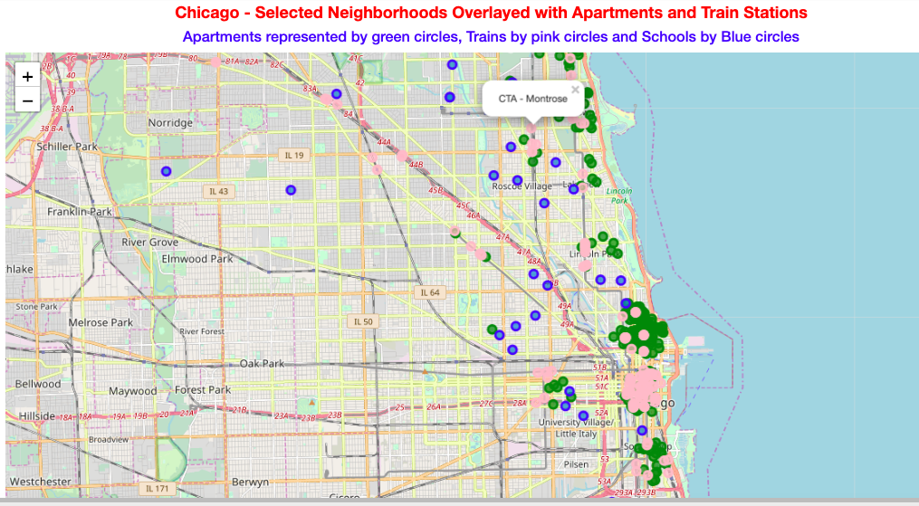
* 
* 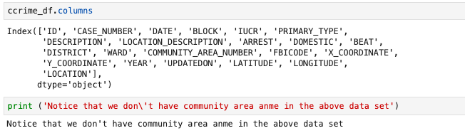
* I will join the Socio-Economic data and the Crime data to match the Community Area Number and get the Community_area_name
* 
* Let us plot the crime locations for a visual check:
* 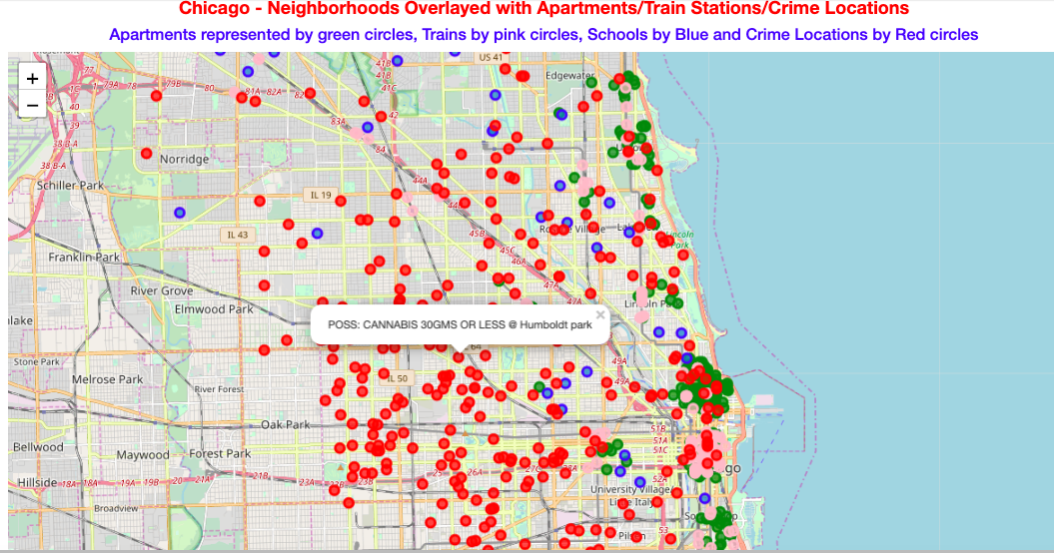
* Observation: There are more crime locations in "other" parts of Chicago than in the parts that we have been focusing on. In the above map the neighborhoods we are interested in have the schools (blue), train stations (pink) and apartments (green) displayed.
* Let us plot the crime data only for the communities in focus
* 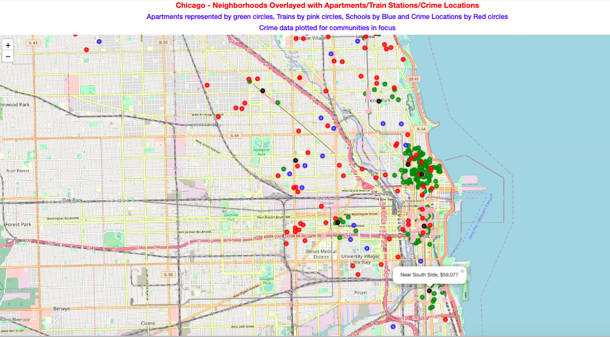
* Observations:
* 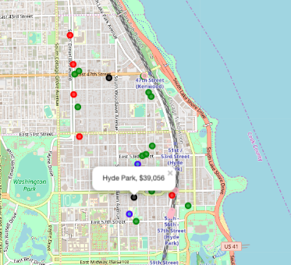
* Hyde Park is a candidate for further investigation
  + Area has low crime
  + Area has a good school: William H Ray Elementary School
  + Easy access to South Shore Commuter Train
  + Solstice on the Park <https://www.apartments.com/solstice-on-the-park-chicago-il/v2f4lpe/>
  + The BlackWood apartments <https://www.apartments.com/the-blackwood-chicago-il/eddsdwm/>
  + The Versailles Apts <https://www.apartments.com/the-versailles-apartments-chicago-il/6dg2tts/>
* 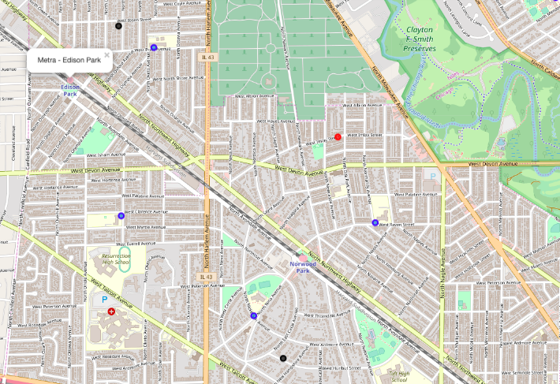
* Edison Park and Norwood Park are also candidates for further investigation:
  + Area has low crime
  + Good schools: Norwood Park Elementary School, Edison Park Elementary School
  + Easy access to Metro: Edison Park and Norwood Park (Metra 624)
  + Foursquare did not show any apartments, but a search on [www.apartments.com](http://www.apartments.com) had a ton of hits
  + 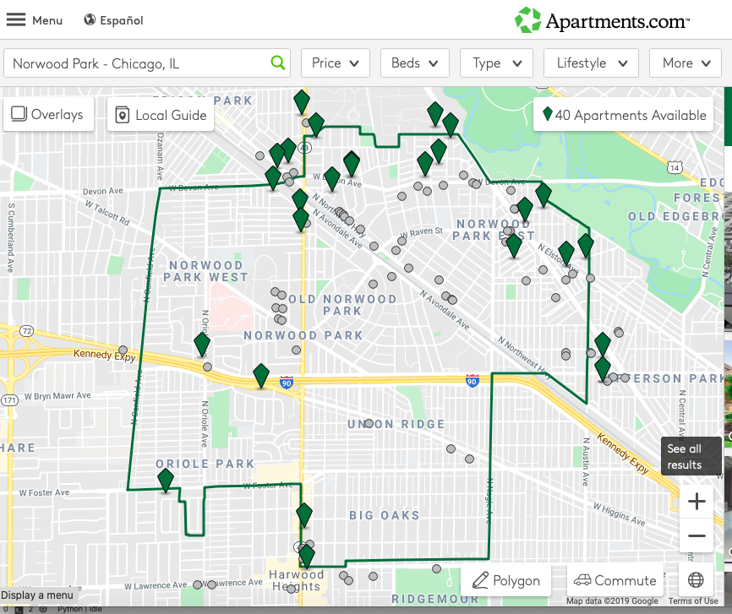
* 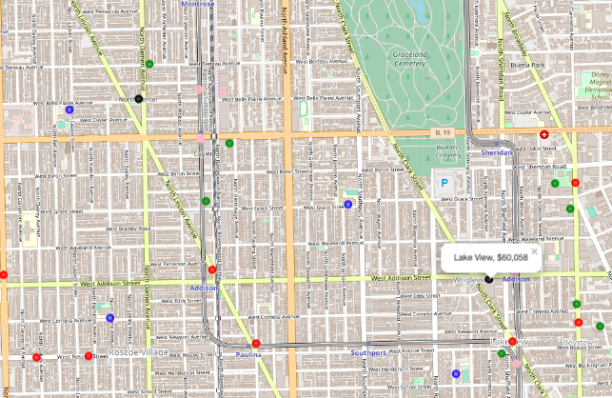
* North Center and Lake View neighborhoods deserve further investigation:
  + Augustus H Burley Elementary School, Hawthorne Elementary School, James G Blaine Elementary School, John C Coonley Elementary School, John J Audobon Elementary School are all in the vicinity
  + CTA: Addison, CTA Montrose, CTA Irwing Park are all close by
  + Foursquare picked up a few apartments such as: 828 W Grace, Halstead Flats, Elaine Place, 800 West Cornelia
  + 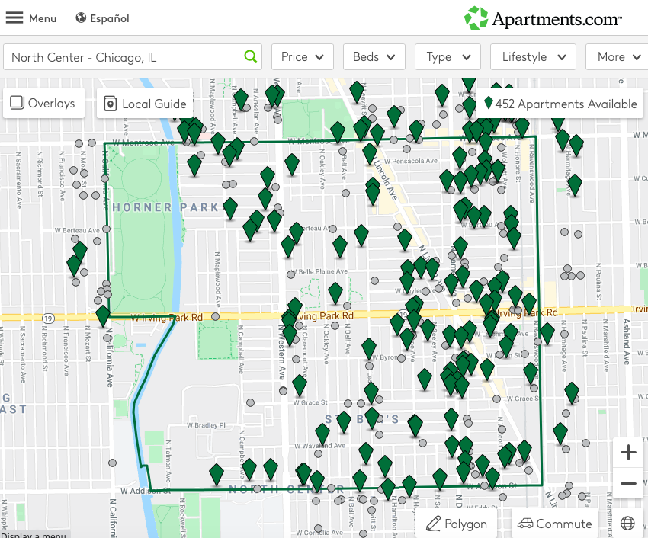

1. **Observations and Recommendations**

* Foursquare did not display many apartments, whereas a search on [www.apartments.com](http://www.apartments.com) produced a huge list of candidate apartments in each of the neighborhoods that I focused on. It is possible that Foursquare is not the most appropriate tool in this case. However, for the purposes of the assignment it did provide us with sufficient number of hits on apartments and train stations.
* For the purposes of this assignment the data sets used were OK. However, the data we used is from public sources and dated. In a real-life-scenario (and for business purposes) we should look for exhaustive and current data.
* Quality of data:
  + Even though we were looking for apartments and train stations Foursquare returned extraneous / irrelevant data. We were able to inspect for such anomalies and take corrective action by deleting (e.g. Mobile Phone Shops) or altering the data (Train same as Train Station). One wonders “what if I am not able to catch bad data?”
* ChicagoGeoJson data was working while I was developing the Notebook, but in the last minute the choropleth maps stopped displaying. Dependence on third party datasets whose structure may change will cause stability issues with solutions. One should pick data sources from reputable/reliable sources.

1. **Conclusion**

Purpose of this project was to identify neighborhoods in the Chicago area that are candidates to move to.

Certain basic conditions had to be met: good schools, low-crime area, higher per-capita income locality, etc. I used publicly available information to narrow down the neighborhoods. At each stage, I used visual aids – Folium , Choropleth maps – to validate and draw observations.

Once the neighborhoods were selected, I used Foursquare data to identify apartments and train stations. I observed that the Foursquare data was not rich in apartment information in some localities. However, this was not an impediment because apartment information is available through alternative sources.

This exercise is expected to assist stakeholders to narrow the search for neighborhoods to move into. Final decision on choosing an apartment will be made by stakeholders based on visiting apartments in the neighborhoods of interest.

I am sure many other people move frequently and are in search for good localities to move into. I hope such an analysis would benefit others also. In the future, we can harden the solution to other cities also.

1. **GitHub Links**

Here is the link to my Notebook on my GitHub repository:

<https://github.com/RajaramChalla/TorontoClusters/blob/master/Capstone_Final_Assignment%20-%20Chicago%20Neig.ipynb>

Please use nbviewer to view the Notebook

<https://nbviewer.jupyter.org/> Paste the above Notebook link into the text box on this viewer web page.

Here is the link to the presentation file:

<https://github.com/RajaramChalla/TorontoClusters/blob/master/Capstone%20Final%20Assignment%20-%20Presentation.pptx>

Here is the link to this report

<https://github.com/RajaramChalla/TorontoClusters/blob/master/Capstone_Project_Final_Assignment_Report_by_Rajaram_Challa.docx>

Here is the pdf version of this report

<https://github.com/RajaramChalla/TorontoClusters/blob/master/Capstone_Project_Final_Assignment_Report_by_Rajaram_Challa.pdf>

1. **References**

## Chicago Public Schools (CPS) - Progress Report Cards

The city of Chicago released a dataset showing all school level performance data used to create School Report Cards. The dataset is available from the Chicago Data Portal:

<https://data.cityofchicago.org/Education/Chicago-Public-Schools-Progress-Report-Cards-2011-/9xs2-f89t>

A static copy of this database (.csv format) can be downloaded from:

<https://ibm.box.com/shared/static/f9gjvj1gjmxxzycdhplzt01qtz0s7ew7.csv>

This dataset includes a large number of metrics. A pdf document that describes the CPS data is at:

<https://data.cityofchicago.org/api/assets/AAD41A13-BE8A-4E67-B1F5-86E711E09D5F?download=true>

Here is an extract of description of the attributes. Attributes used in my analysis are in red font.

| Column Name | Description | Type |
| --- | --- | --- |
| School ID |  | Number |
| Name of School |  | Plain Text |
| Elementary, Middle, or High School | ES indicates elementary school; MS indicates middle school; and HS indicates high school | Plain Text |
| Street Address |  | Plain Text |
| City |  | Plain Text |
| State |  | Plain Text |
| ZIP Code |  | Number |
| Phone Number |  | Plain Text |
| Link |  | Website URL |
| Network Manager |  | Plain Text |
| Collaborative Name |  | Plain Text |
| Adequate Yearly Progress Made? |  | Plain Text |
| Track Schedule |  | Plain Text |
| CPS Performance Policy Status | This reflects whether or not your school is on probation this year. More information on the CPS Performance Policy may be found online at [www.cps.edu](http://www.cps.edu/). N/A: Not applicable NDA: No data available | Plain Text |
| CPS Performance Policy Level | Level 1 indicates the highest performing schools. Level 2 indicates a middle-performing school that needs improvement. Level 3 indicates the lowest performing schools. NDA indicates no data available. | Plain Text |
| Healthy Schools Certified? |  | Plain Text |
| Safety Icon | Student Perception/Safety category from 5 Essentials survey | Plain Text |
| Safety Score | Student Perception/Safety score from 5 Essentials survey. These scores range from 1 to 99. For more information on these scores, please see the My Voice, My School survey available at [www.ccsrsurvey.uchicago.edu/2011](http://www.ccsrsurvey.uchicago.edu/2011). | Number |
| Parent Environment Score | Parent Perception/Environment score from parent survey. These scores range from 30 to 70. For more information on these scores, please see the parent survey information available at [www.cps.edu](http://www.cps.edu/). | Plain Text |
| … | … | … |
| Average Student Attendance | Average daily student attendance % | Number |
| Rate of Misconducts (per 100 students) | # of misconducts per 100 students | Number |
| … | … | … |
| Latitude |  | Number |
| Longitude |  | Number |
| Community Area Number |  | Number |
| Community Area Name |  | Plain Text |
| Ward |  | Number |
| Police District |  | Number |
| Location |  | Location |

## Chicago Socio Economic Indicators

Description and a discussion on the Socio-Economic Indicators is available at:

<https://data.cityofchicago.org/Health-Human-Services/Census-Data-Selected-socioeconomic-indicators-in-C/kn9c-c2s2>

The associated data file is located at 'https://data.cityofchicago.org/resource/jcxq-k9xf.csv'

Here is an extract of description of the attributes. Attributes used in my analysis are in red font.

| Column Name | Description | Type |
| --- | --- | --- |
| Community Area Number |  | Number |
| COMMUNITY AREA NAME |  | Plain Text |
| PERCENT OF HOUSING CROWDED | Percent occupied housing units with more than one person per room | Number |
| PERCENT HOUSEHOLDS BELOW POVERTY | Percent of households living below the federal poverty level | Number |
| PERCENT AGED 16+ UNEMPLOYED | Percent of persons over the age of 16 years that are unemployed | Number |
| PERCENT AGED 25+ WITHOUT HIGH SCHOOL DIPLOMA | Percent of persons over the age of 25 years without a high school education | Number |
| PERCENT AGED UNDER 18 OR OVER 64 | Percent of the population under 18 or over 64 years of age (i.e., dependency) | Number |
| PER CAPITA INCOME | Community Area Per capita income is estimated as the sum of tract-level aggregate incomes divided by the total population | Number |
| HARDSHIP INDEX | Score that incorporates each of the six selected socioeconomic indicators (see dataset description) | Number |

## Chicago Crime Data

The above referenced Chicago City web site also has data on the crime statistics. The associated data file is located at <https://ibm.box.com/shared/static/svflyugsr9zbqy5bmowgswqemfpm1x7f.csv>

This dataset reflects reported incidents of crime (with the exception of murders where data exists for each victim) that occurred in the City of Chicago from 2001 to present, minus the most recent seven days.

While this dataset is quite large - over 1.5GB in size with over 6.5 million rows, for the purposes of this assignment a much smaller sample of this dataset was use, available at the above link. A detailed description of this dataset and the original dataset can be obtained from the Chicago Data Portal at:https://data.cityofchicago.org/Public-Safety/Crimes-2001-to-present/ijzp-q8t2

Of the attributes compiled by the city: 'ID', 'CASE_NUMBER', 'DATE', 'BLOCK', 'IUCR', 'PRIMARY_TYPE', 'DESCRIPTION', 'LOCATION_DESCRIPTION', 'ARREST', 'DOMESTIC', 'BEAT', 'DISTRICT', 'WARD', 'COMMUNITY_AREA_NUMBER', 'FBICODE', 'X_COORDINATE', 'Y_COORDINATE', 'YEAR', 'UPDATEDON', 'LATITUDE', 'LONGITUDE', 'LOCATION'

For our analysis we will use: 'DESCRIPTION', 'COMMUNITY_AREA_NUMBER', 'LATITUDE', 'LONGITUDE'. The community area name is not available in this data set. We will use 'COMMUNITY_AREA_NUMBER' from the crime data set to join with the Socio-Economic Data set to get the Community_Area_Name.

## Chicago Rapid Transit System The Chicago “L”

[**Chicago Transit Authority CTA (CTA-L)**](https://www.transitchicago.com/)

